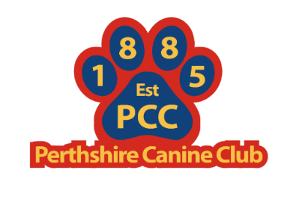
admin@perthshirecanineclub.co.uk perthshirecc@gmail.com
Nether Common, Rait, www.perthshirecanineclub.co.uk
Perthshire, PH2 7RU
Perthshire Canine Club

Application for Membership of Perthshire Canine Club
MEMBERSHIP COSTS - The current annual subscription runs from 1st January to 31st December 2024.
There are three categories of Membership: Single £5, Joint £6, or Junior £2.
- Joint Membership is available to spouses or two persons resident at the same address.
- Junior Membership is available to ages 6 - 16 years.

MEMBERSHIP APPLICATION FORM- AGM LAST TUESDAY IN MAY, TULLOCH INSTITUTE/ONLINE, PERTH 8.30PM
I/We apply to be admitted as a member/s of the Club, subject to the terms of the Club’s Constitution (available on the website), and I/We agree to abide by that Constitution. I/We enclose remittance for the relevant fee. (If paying by Paypal please use the Friends & Family option OR Paying by BACS please use your Surname as Reference
PLEASE COMPLETE THE FOLLOWING IN BLOCK CAPITALS
Full Name, Including Title: 1)…………………………………………………… 2)…………………………………………………………
Address: ………………………………………………………………………………..
………………………………………………………………………………….
Post Code: ………………… Tel. No: ……………………….. Date: ……………….
Signature 1) ……………………………………………………………. Signature 2) …………………………………………………………………
E-mail address: …………………………………………………………………………..(This is our preferred method of contact)
Type of Membership (i.e. Single/Joint/Junior)
Date of Birth (please specify when applying for Junior membership): ……………….
Breed(s) owned: ………………………………………………………………………….
Payment Method Cheque □ Paypal(perthshirecc@gmail.com) □ BACS Sort Code 87 44 15 Ac No 00000416□
Canine Interests (Please tick where appropriate):
Showing □ Stewarding □ Education□ Monday Mutterings □ Judging □ Ring Craft □
Please tick if you would like a Copy of: The Club’s Constitution □ GDPR □ Safeguarding Policy □
(Personal Information held for the calendar year of membership, this is not shared and only used for club purposes)

